**Spiceworks – Topic page**

Scrap the same data for all products (Here it is 138 products in networking category in the image below)

Links for different product categories:

* [Networking](https://community.spiceworks.com/networking/product/reviews?selector_query=dell)
* [Storage](http://community.spiceworks.com/storage/product/reviews?utf8=%E2%9C%93&source=channel_search_bar&selector_query=dell)
* [Servers](•%09http:/community.spiceworks.com/hardware/server-storage/reviews?selector_query=dell)

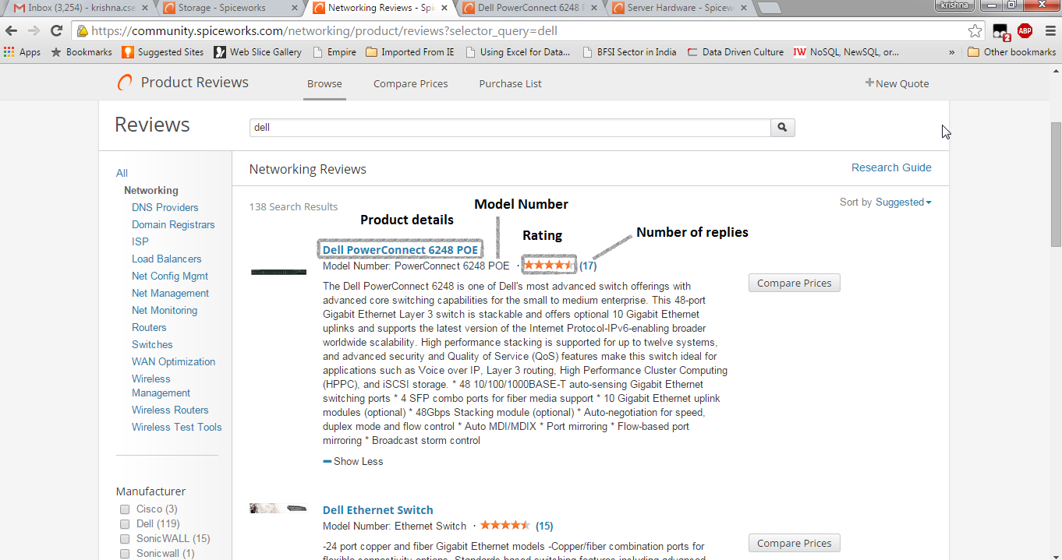

Don’t capture anything from here. Click on the list of the products.

When you click on any of the products, you enter into product page where you need to scrap the data as per below.

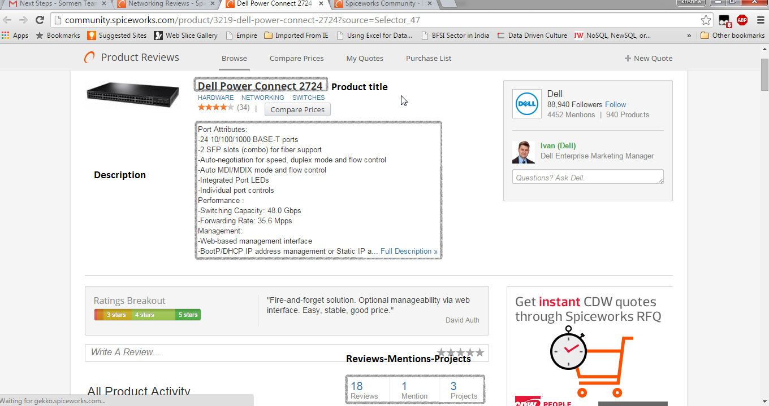

Capture the product title, total number of mentions and mention link after clicking on mentions

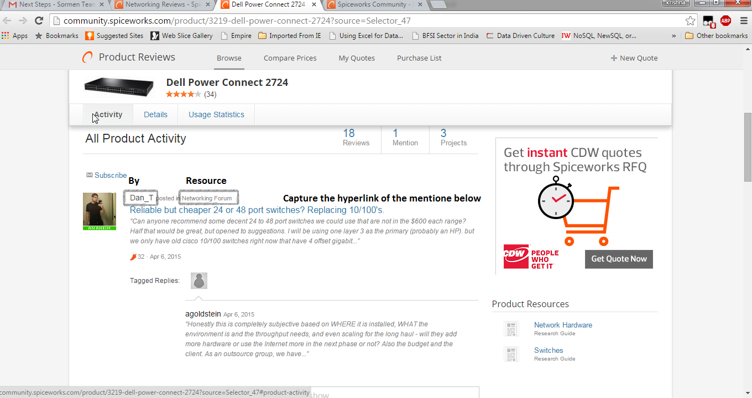

Go to the mention link and capture mention title, mention content, mention by, mention at, resource, total number of replies. For each reply capture reply-by, reply-at and reply as below.

Capture all the mentions (hyperlinks) of every product listed in the spice works.

Capture the following data from the mentions

